(Approx. 1196 words)

Virtual Classes – are Real
By Phil Sorrentino, Contributing Writer, Sun City Center Computer Club
www.scccomputerclub.org
philsorr (at) yahoo.com

That almost sounds like an oxymoron like “Jumbo Shrimp” or “deafening silence.” Well, the coronavirus has elevated teleconferencing to a level never seen before or maybe even ever expected. Almost everyone, by now, knows of Zoom and other computer Apps like GoToMeeting for teleconferencing. Zoom appears to have a lion’s share of the business. If you’re not quite sure what Zoom is, here is what Wikipedia says. “Zoom Video Communications, Inc is an American communications technology company. It provides video telephony and online chat services through a cloud-based peer-to-peer software platform and is used for teleconferencing, telecommuting, distance education, and social relations”. For many of us, we can think of it just as an “easier to use” Skype. Two years ago, I did a presentation to a User Group on the west coast using Zoom (surprisingly not Skype). It was the first time I had heard of or used Zoom. Now Zoom has over 40% of the teleconferencing market. (Boy did I miss an investment opportunity. Zoom went public in March 2019 at $36 and is now around $250.)

Before the virus, teleconferencing was used mostly in the corporate world. But now everyone is familiar with it, from the seniors who are self-quarantining to avoid crowds, to elementary school students and teachers staying at home to avoid classrooms and crowded schools, to employees who are working from home to avoid the workplace gathering places like the coffee pot, the copier, and the water cooler.

Almost all of us are trying to avoid groups of people where the virus might easily be transferred. I recently needed to go to a shopping mall, and I was amazed to see how empty it was. We are staying away from gathering places. (Although the beaches do still seem to be pretty crowded.) So, now that we are not going out and gathering as much, we are staying home a lot more, which gives us a lot more time to learn new things. How many of us have taken up a new instrument or are learning a new language? Now’s the time to learn how to play that guitar or keyboard you bought a few years ago. Well, language and instruments may be too much to expect but we probably can more easily learn about things we are involved in or are using daily, like our computer and our phone. And that is where virtual classes can be of some help.

Virtual classes are educational classes held remotely using teleconferencing software like Zoom or GoToMeeting, or others. With an in-person class, students and teachers gather in a classroom and interact there. With a Virtual class, we interact through our computer Clients (apps) which are then gathered together in a Server. (Remember Client-Server Technology?) Each of our computers is connected to the server via the internet, and it is the Server software that provides the magic that lets us all share the Video and Audio from our client computer’s cameras and microphones. The popular servers support many different clients. You can attend a virtual class using almost any device such as a Windows computer, an Apple computer or an iPhone or iPod, an Android phone or tablet, a Chromebook, or even a Linux computer. A reliable, fast internet connection will greatly improve the experience. A wired connection to your router may be desirable, but not very common. Fortunately, modern wi-fi is typically more than adequate. (But unfortunately, not everyone has the latest wi-fi, especially if it is being supplied by
the Internet Service Provider.)

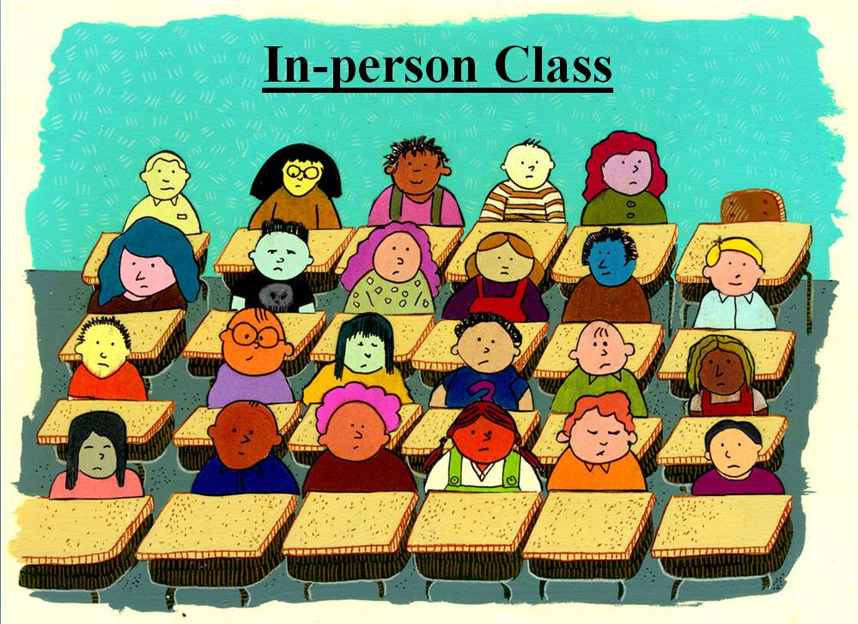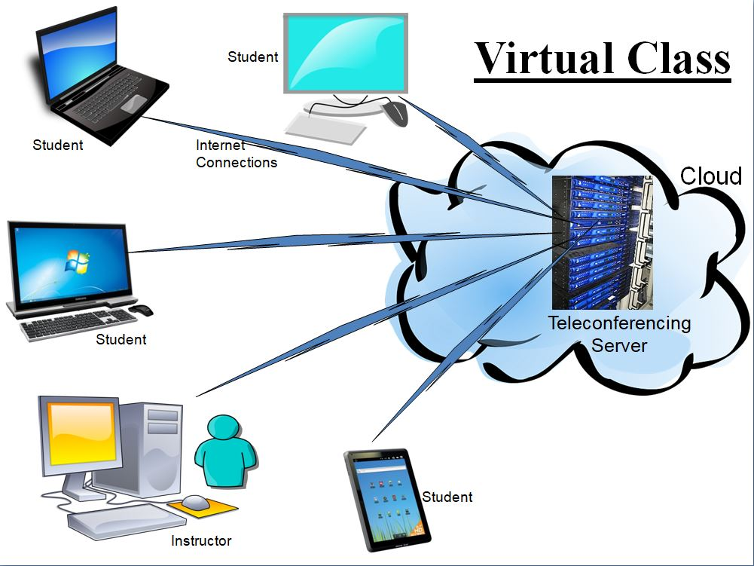

The internet connections to the server in the cloud allow us to interact “virtually” and avoid gathering together. The server “connects” each of us to each other. And the server presents a classroom presentation to each of us (the Users) so we can see who is participating in the virtual class. (There are controls on the Users screen that allow the Video and Audio, separately, to be turned on or off. The audio control is the “mute” control, mute turns the audio off, and un-mute turns the audio on. The video control is typically just Video on or off, though initially, it might show up as “join with Video”.)

The classroom presentation also has some different ways of showing the group of participants. Gallery view, as it is sometimes called, shows each of the participants (if their video is on) in a box on the screen. (If a Participant’s video is off, the box will just have the User Determined name.) The screen is divided among the number of participants, so as the number of participants gets larger it might be harder to determine who is in attendance, though each participant box does show the name. Another classroom presentation shows predominantly the person who is speaking with others shown in small boxes to the side or bottom, sometimes called “speaker view”. If there are a lot of speakers this might be helpful, though if someone has a slow internet connection, it might end up less helpful, due to the delay.

For any Virtual class, a very comprehensive PowerPoint presentation would be recommended, in general, to guide the class through the subject matter. Some classes readily lend themselves to the Virtual format. These are the “lecture” type of classes where there are no “hands-on exercises” to be undertaken. Demonstrations of hardware or software can mostly be accomplished using a “Share screen” feature that lets the instructor share the contents of his computer screen with all the participants. (Software on a particular device can be easily demonstrated by having that device as another class participant and allowing it to share its screen.) When the instructor does this, the instructor’s screen shows up on every participant's screen.

So, it’s just like watching the big screen TV in front of the classroom, only everyone sees the teacher’s screen on their computer screen, at their location. A class like “Cut the Cord” works well as a virtual class because it is mostly lecture. Other classes, that are more interactive, may not lend themselves as easily. A class that requires a lot of interaction may be difficult as a virtual class. This type of class may be more like a discussion group and maybe more dependent on having a definite agenda and a very strong moderator/instructor. Smaller class sizes may help this type of class be successful. The Special Interest Group on smartphones is an example of this type of class. All the participants of this class are encouraged to bring questions and ideas to the class for discussion, and it is anticipated that everyone will have an opportunity to speak. Questions from the class participants in any class are handled with either a “Chat” feature where the question can go to all participants or a specific participant or a “Raise Hand” feature that shows up on the screens to get the participant’s attention.

Hopefully, this brief description (and time spent watching YouTube videos on the subject) will give you the courage to participate in a virtual class the next time an interesting one is offered.

